**BH RPA**

**Report CSB for S&OP_BOT project**

**Revision History**

|  |  |  |  |
| --- | --- | --- | --- |
| **Date** | **Revision** | **Author** | **Description** |
|  |  |  |  |
|  |  |  |  |
|  |  |  |  |

**Contents**

[Contents………………………….…………………………………………………………………………………………………………………………………………….4](bookmark://_Toc23929860)

[Introduction………………………………………………………………………………………………………………………………………………………………….5](bookmark://_Toc23929861)

[Intended Audience……………………………………………………………………………………………………………………………………………..5](bookmark://_Toc23929862)

Accompanying Material………………………………………………………………………………………………………………………………….6

[Functional design…………………………………………………………………………………………………………………………………………………… 6](bookmark://_Toc23929864)

[Process Description…………………………………………………………………………………………………………………………………………….6](bookmark://_Toc23929865)

[Current Process……………………………………………………………………………………………………………………………………………………..6](bookmark://_Toc23929866)

[Robotic Process……..…………………………………………………………………………………………………………………………………………….. 6](bookmark://_Toc23929867)

[Connected Systems/Components………………………………………………………………………………………………………………..8](bookmark://_Toc23929868)

[Connected Systems…………………………………………………………………………………………………………………………………………….8](bookmark://_Toc23929869)

[Software……………………….……………………………………………………………………………………………………………………………………………..8](bookmark://_Toc23929870)

[Schedule………………………………………………………………………………………………………………………………………………………………………9](bookmark://_Toc23929871)

[Technical Design……….…………………………………………………………………………………………………………………………………………….. 10](bookmark://_Toc23929872)

[Logging……………………….……………………………………………………………………………………………………………………………………………….10](bookmark://_Toc23929873)

[Assets…………………………..……………………………………………………………………………………………………………………………………………….10](bookmark://_Toc23929874)

[Exception handling…………………………………………………………………………………………………………………………………………………...11](bookmark://_Toc23929875)

[Workflows…………………………………………………………………………………………………………………………………………………………………………….. 12](bookmark://_Toc23929876)

Custom Code Requirements……………………………………………………………………………………………………………………………………..13

Breakdown of Process steps……………………………………………………………………………………………………………………………………….13

**Introduction**: **-** Yet to decide after complete process walk through

**Intended Audience: -**Yet to update

**Accompanying Material: -** Web Application, Excel, Outlook.

**Functional d****esign**

Process Description

In Scope:

**Step 1: -**

1. Login to website <https://tableau.bhicrop.com/#/Site/OG_DTS/Views/SOPreportCSBVisibilityonquote/CSBProvisionalTrackerforComOpsSlottingBot?.iid=2>
2. Click on “**CSB Provisional Tracker for ComOps/Slotting BOT**”

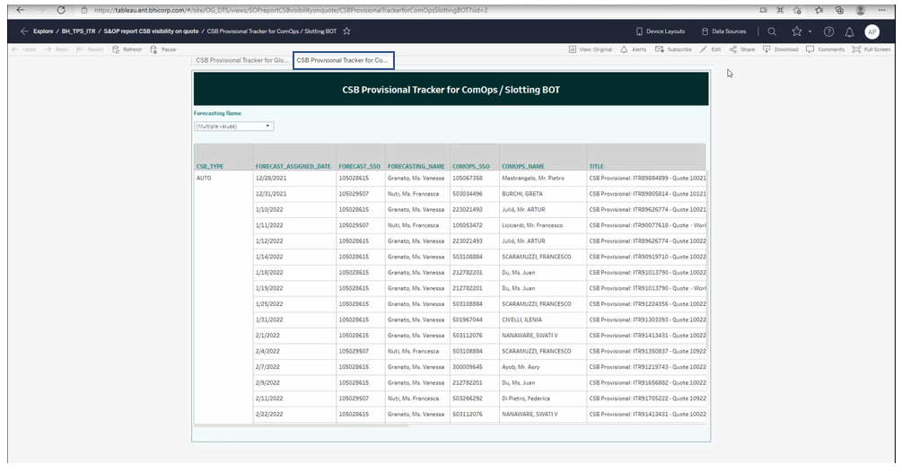

1. Download the data with specific format

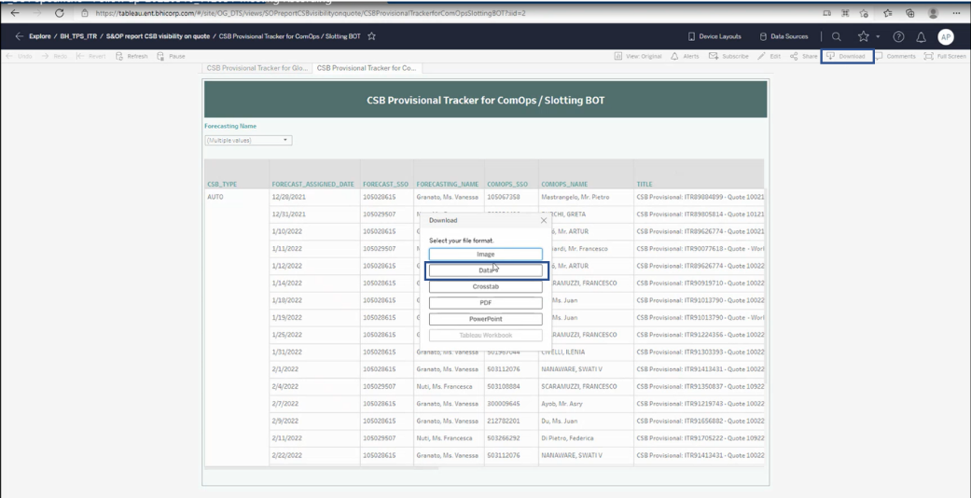

1. We can be able to see the new data pop up as shown in below mentioned snapshot. Select the **full data**, **check the show all column** and click on **Download all rows as a text file** it will save automatically in downloaded folders (if we want to save, we can save if specific folder).

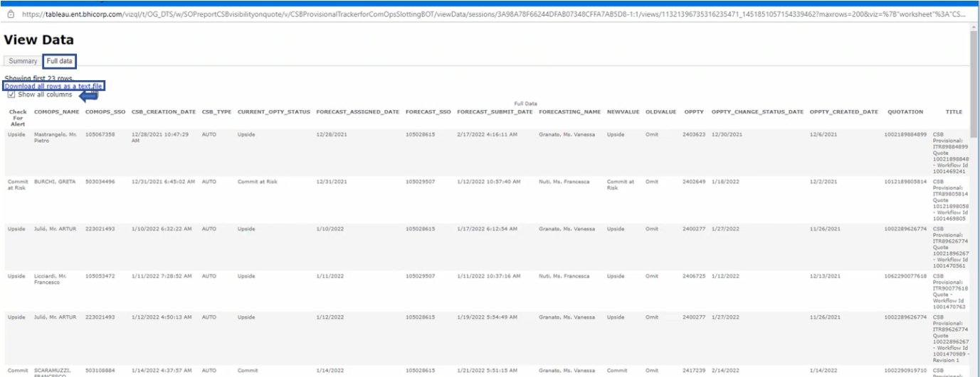

**Step: -2**

**Sending Mail to “Use Email Template_Upside.docx” and “****Use Email Template_Commit & Commit at Risk.docx”**

1. Open Excel File.
2. Apply filter at column “O” with today -1 date and will able to see few column
3. At column “K” check the value it should be “**Upside** **or** **Commit at Risk or Commit”**
4. If Column “K” equals to “**Upside**” then use “**Use Email Template_Upside.docx”**
5. If column “K” equals to “**Commit at Risk or Commit**” then use “**Use Email Template_Commit & Commit at Risk.docx**”
6. To: Take from the column “**B**”
7. CC: Take from the column “**I**”
8. Subject: This is form **Use Email Template_Upside.docx.**
   1. **# OPPTY** Replace with **OPPTY &**  **Column “N”** from excel File
   2. **Quote # QUOTATION** Replace **with Quote # & Column “Q”** from Excel File
9. Body:This is from **Use Email Template_Upside.docx.**
   1. **# OPPTY** Replace with **OPPTY &**  **Column “N”** from excel File
   2. **Quote # QUOTATION with Quote # & Column “Q”** from Excel File
10. Send mail. And repeat for all aviliable numbers of rows.
11. If Column “K” not equal to “**Upside** **or** **Commit at Risk or Commit**” then send alert mail.

Scope Excludes:

If column “K” not having below mentioned list then it convert to business exception and sending a mail (**Bascially it won’t come if come need to drop a mail to customer**).

List: -

1. **Upside b. Commit at Risk c. Commit**

**Process Assumptions**

**Current Process**

<Flow Chart of AS_IS Process>

**Robotic Process**

<Flow chart of To_BE Process>

**Connected Systems/Components**

Connected Systems

|  |  |  |  |  |  |
| --- | --- | --- | --- | --- | --- |
| **System Name** | **Usage** | **Path** | **Contact/Method for Requesting Access** | **Access?** | **ID** |
| **Tableau (Dev)** | Downloading Data | [Path](https://tableau.bhicrop.com/#/Site/OG_DTS/Views/SOPreportCSBVisibilityonquote/CSBProvisionalTrackerforComOpsSlottingBot?.iid=2) | Solv/Business Team | No |  |
| **Tableau (Prod)** | Downloading Data | Yet to receive | Solv/Business Team | NO | Yet to receive |
|  |  |  |  |  |  |
|  |  |  |  |  |  |

**Software**

|  |  |  |
| --- | --- | --- |
| **Name** | **Version** | **Source** |
| **Outlook** | 2016 |  |
| **Chrome** | Yet to decide the browser |  |
| **Excel** | 2016 |  |

**Process Considerations**

**Note: -** Yet decide with Business Team

|  |  |
| --- | --- |
| Expected volume of output |  |
| Transaction Run Time |  |
| Total Run Time |  |
| Number of Bots |  |
| Use of Queue |  |
| Bulk Process |  |
| Ad-Hoc Request Support |  |

**Schedule**

**Note: -** Yet decide with Business Team

**Note: -** Yet to design

**Technical Design**

**Logging**

* Transaction log

* Task logs

**Assets**

**Note: -** Yet to create

|  |  |
| --- | --- |
| **Asset Name** | **Description** |
| **11_B_Credential** | **Credentials** |
| **11_B_FileUploadURL** | **Url for File upload** |
| **11_B _Credential** | **Credential** |
| **11_B _URL** | **Oracle URL** |
| **11_B_Email_Credential** | **Credential for mailbox** |

**Exception handling**

**Note: -** Yet to create

* Operational Exceptions
* Functional Exceptions
* Coding Exceptions

**Workflows**

**Note: -** Yet to create

|  |  |  |  |  |  |
| --- | --- | --- | --- | --- | --- |
| **Workflow Name** | **Description** | | **Input** | **Output** | **Reusability?** |
| **Load** |  |  | |  |  |
| **searchOrederNumber** |  |  | |  |  |
| **EnterAttachmentDetails** |  |  | |  |  |
| **UploadPDfFile** |  |  | |  |  |
| **ConfirmUpload** |  |  | |  |  |
| **LoginToOracle** |  |  | |  |  |
| **BoxLogin** |  |  | |  |  |
| **BoxUpload** |  |  | |  |  |

**Custom Code Requirements**

*NA*

**Breakdown of Process Steps**

**Note: -** Yet to create

|  |  |  |
| --- | --- | --- |
| **Process Step** | **RPA Task** | **Complexity** |
| Read mail |  |  |
| Download the attachment |  |  |
| Login to application |  |  |
| Search Order number |  |  |
| Upload file |  |  |
| Create status file |  |  |
| Send mail |  |  |